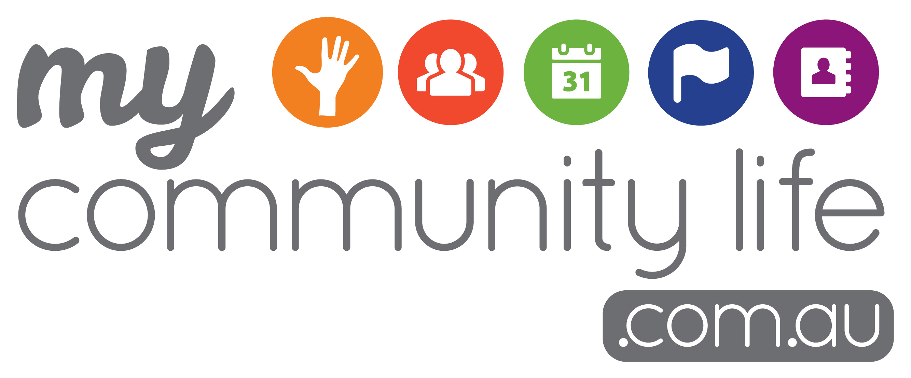

Quick Reference Guide


Promote your community group, events and volunteering opportunities for free using the My Community Life website. You can get started in just four easy steps!

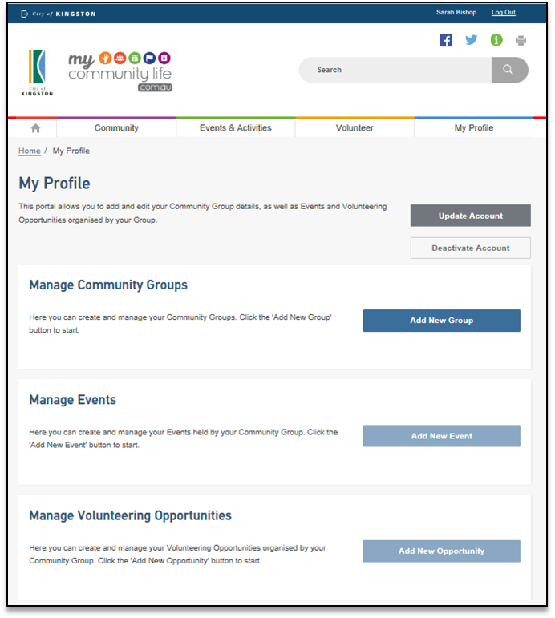
Step One

Visit www.mycommunitylife.com.au and select ‘My Profile’ to start.

Step Two

Log in with a user account
- New user – click and complete the form; or
- Existing user – log in using your registered email address and password

Step Three

Tips to get your page noticed!

- Remember, you are writing to people that may know nothing about what you do. If you were them, what would you want to know?
- Be creative and keep your information simple. Clearly describe your Community Group, Events, Activities and Volunteer positions.
- Use ‘Key Words’ that commonly describe your group or event to help your listing show up better in search results (e.g. dancing, dance, cards, tennis, running, run, jog etc.)

Turn over for more top tips on getting
the most out of the site →
Create a Community Group listing to promote your group
- Click ‘Add New Group’ and complete the form
- Click ‘Preview’ to check page, then click ‘Submit’
Note:
- You cannot move to Step Four until this page has been approved by Kingston Council. Please allow 3 business days
- If you already have a community group page, click on the ‘edit’ button to update the details
Step Four
List/edit your events, activities or volunteer positions
- Click ‘Add New Event’ or ‘Add New Opportunity’ and complete the form
- Live or deactivated event pages can be edited and re-used, click on the ‘Edit’ button and make changes
- Click ‘Preview’ to check the page, then click ‘Submit’

Top Tips


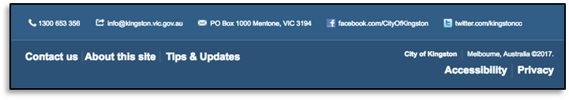
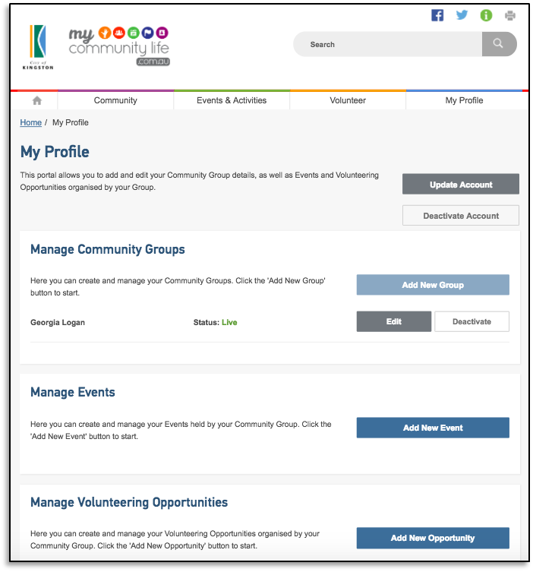
Community Group Page
Event/Activity Page(s)
Volunteer Opportunity(ies)
- This is your group’s profile page. For general information about your group (you can only have one of these per group)

- List all your event details, including date, time, costs and why people should attend (you can add multiple)
- List the volunteer role, providing a role description and timeframe (you can add multiple)
Email address
Use a generic email address for your group so more than one person can access the email inbox

Password
Your password must have at least one capital letter, number and special character – e.g. Password1#

Preview
To preview your page you will need to enable ‘pop-ups’. For instructions go to the Tips & Updates page then see related links

Images
All images/photos uploaded to the site must be 300(w) x 275(h) pixels

Getting information in the right spot
After you’ve created your ‘Community Group’ and the page has been approved, you then Add your ‘Event/Activity’ or ‘Volunteer Opportunity’ as a separate page

Need more help?
- Detailed step-by-step guides (top of website)
- Latest tips and updates (bottom of website)
- Call the MCL team on 9581 4809

Don’t forget to double check all the information by ‘previewing’ it before you hit ‘submit’

Below are some handy tips and tricks to use when setting up your listings on My Community Life.

