Uploading Content
User Guide
JULY 2019

www.mycommunitylife.com.au

My Community Life is supported by the Social Development Team at Kingston Council.

You can contact us on:

Phone: 9581 4809

Email: mycommunitylife@kingston.vic.gov.au

The City of Kingston acknowledges the funding contribution made by the State Government of Victoria for the development of the My Community Life website, supporting resources and the delivery of community training sessions.

Contents
1. Introducing My Community Life 4
The importance of the Internet 4
Why use My Community Life? 4
How to use this guide 6
Further information and assistance 6

2. Overview of the Site 7
Accessing the site 7
Navigating the site 7

3. Uploading content onto the site 9
Step 1 – Register a user account/log in 9
Step 2 - Creating and editing a community group 14
Step 3 – Adding and editing events and volunteer opportunities 20

4. Removing content from the site 28
Deactivating or archiving a community group listing, events and volunteer opportunities 28
Deactivating your user account/ log in 30

5. Getting the most from MCL 31

- Introducing My Community Life
My Community Life (MCL) is an online directory for community groups and organisations in the City of Kingston which can be easily accessed on your computer, tablet or smart phone.
It is designed to be a ‘one stop shop’ for all groups, activities, events and volunteer opportunities within the municipality – replacing the former hard copy community directory, and providing even more information and benefits.
Any not-for-profit community group, organisation or club can use the site if they:
- are based in, or are in close proximity to, the City of Kingston municipality;
- provide activities or services within the City of Kingston; and
- whose membership, events or volunteer opportunities are open to the Kingston community.
For the purposes of this guide, the term ‘community group’ has been used to refer to all groups, clubs and organisations that meet the above criteria.
MCL has been developed by Kingston Council as a way of supporting and connecting the local community and links directly from the official Kingston Council website. It is also highly visible on Google and other search engines.
  - The importance of the Internet
Recent statistics show that more than 99% of Australians use the Internet and 83% of Victorians use it at least once every day (Sensis Social Media Report 2017).
Community groups that do not promote themselves or their activities on the Internet (either via websites or social media) are missing out on a huge audience. Think about how many times you have heard the phrase ‘google it’ when people are looking for information about something (referring to the internet search engine Google). For a majority of people in Australia, Google is the first place they will start looking for information.
  - Why use My Community Life?
My Community Life has been set up to provide all community groups in Kingston with an opportunity to promote themselves and their activities online, giving them access to a much wider audience without needing to establish their own website.
For groups that already have a website or social media presence, the MCL website provides another opportunity for your information to be found and to direct people to your existing online channels. After all, the more people that visit your site, the more likely it will appear higher up in google search results, and the more easily your information will be found by others.
Benefits for community groups and organisations:
- A completely FREE opportunity to promote your group and activities online
- A locally focused site, specifically for the City of Kingston
- Access to a much wider online audience
- Opportunity to attract new members, more attendees at events and recruit new volunteers
- A trusted platform supported by Council that will be widely promoted through the Kingston Your City newsletter, advertisements in the local paper, social media and website
- Search visibility - As a large Kingston Community platform, when people search for groups, community events and volunteering opportunities on Google, My Community Life will appear first. If you are not on this platform your group and events may not get seen.
- Ability to cross-promote - as community platform that will be used by dozens of community groups and hundreds of volunteers there is a real opportunity to cross-promote events and activities on this platform and social media.
- Easy to use and support available
Benefits for individuals in the Kingston community:
- A central place to find information about local community groups, events and volunteer opportunities
- A directory specifically for the local City of Kingston area only
- A council-supported website that contains only reliable, up to date and verified information
- A responsive website that works on smartphones, tablets and laptops making it easy to use anytime anywhere.
  - OUR GOAL
The goal for MCL is to increase social participation in Kingston through the provision of a free accessible website.
To do this we need your participation.
To be a success we need all of Kingston’s community groups to create a profile and upload their events and opportunities. Working together we hope to increase overall participation across the City.
Kingston Council will regularly promote the site to raise awareness of this community resource and to help get visibility for your group and your events.

  - How to use this guide
This guide has been created to help you get the most from the My Community Life website and includes:
- Step-by-step instructions about how to add information to the site
- Tips and tricks for creating easy to find and appealing content
- Advice about how to use this site along with other promotional activities
There are also a series of video tutorials available for you to watch called webinars. These are available through the ‘instructions’ page on MCL, which can be accessed from the green information icon at the top right of the homepage (shown below).
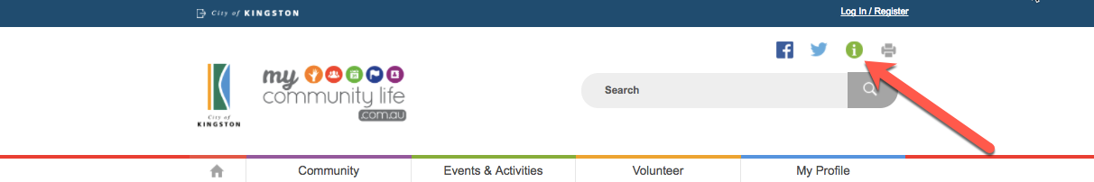

  - Further information and assistance
Contact Council’s My Community Life Team on (03) 9581 4809 or mycommunitylife@kingston.vic.gov.au

This is how MCL will appear on smartphones
- Overview of the Site

  - Accessing the site
To access the My Community Life website, simply type www.mycommunitylife.com.au in the address bar of your internet browser.
  - Navigating the site
Below is an image of the MCL website homepage highlighting the key features and the website navigation menu.
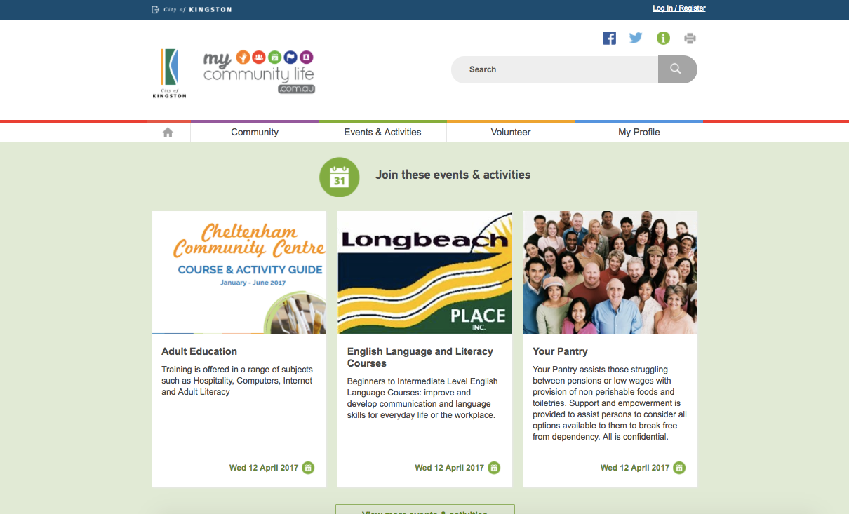
Scroll down the page to see more listings
5
4
3
2
1
1. Main menu:
- Home – icon directs you back to the home page.
- Community – lists all the groups and organisations that have created profiles in MCL.
- Events & Activities – lists all the events and activities uploaded by local community groups.
- Volunteer – lists all the volunteering opportunities uploaded by local community groups.
- My Profile – allows community groups to create a free account then upload a community group profile, events and activities and volunteer opportunities.
2. Search box: find groups, activities or volunteer opportunities related to your interests using key words.
3. Sharing, information and printing: Click on the icons to share the page you are viewing on your Facebook or Twitter account, view instructions for creating your pages, or print the page you are viewing.
4. Logos: Click on the Kingston logo at any time to go to the City of Kingston website, or the MCL logo to take you to back to the MCL homepage.
5. Home page content: Upcoming events and activities and randomly selected groups and volunteering opportunities are displayed on the homepage. Scroll down to see more, click on the view more tabs to go to the relevant listing pages.
6. Footer:
- Contact Us – provides contact details for the MCL site.
- About this site – provides and overview about the purpose of the site and terms and conditions.
- Tips & Updates – provides useful tips; any changes made to the site and links to the newsletter.
- Accessibility – information about accessibility and where to seek assistance.
- Privacy – links to Council’s privacy statement and policy.
6
Click on the arrow to return to the top of the page
- Uploading content onto the site
To add events and volunteer opportunities to the MCL site you must follow these steps in order:

  - Step 1 – Register a user account/log in
To register a user account/log in you need the following:
- An email address (we recommend a generic address so log in details can be shared with others later)
- A password (that meets the requirements outlined on the site)

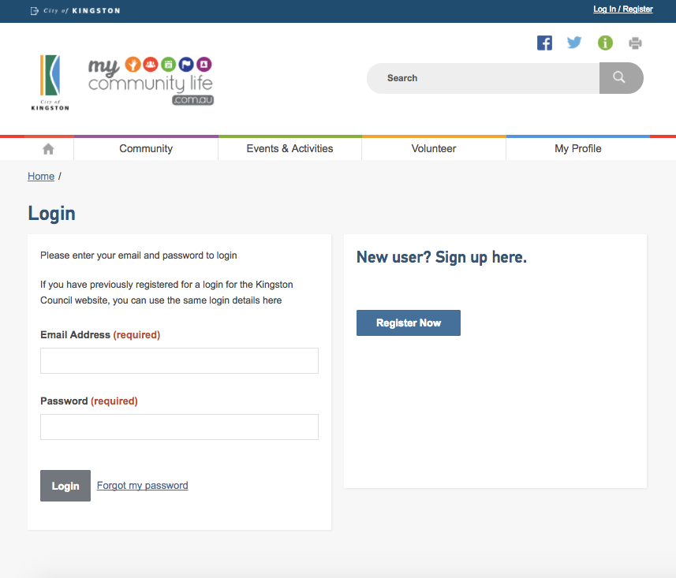
1
43
3
2
- Go to the ‘My Profile’ page
- If you have already created an account/log in, enter the email address and password.
- If you have created an account/log in but you can’t remember your password, click on the ‘Forgot my password’ link to be emailed a link to create a new password.
- If you need to create an account, select the ‘Register Now’ button.
To permanently delete your account please contact the My Community Life Team.
Phone: (03) 9851 4809
Email: mycommunitylife@kingston.vic.gov.au

TIP: Choosing a good password
Your password must be between 8 and 40 characters long. Here are some further tips:
- Use at least one capital letter
- Use at least one number
- Do not make your password obvious (like the name of your group, consecutive numbers or letters, or the word ‘password’)
- If you plan to share the login details with others, a password that means something to the group is more likely to be remembered
You can change your password at any time through the ‘My Profile’ → Update Account section.
TIP: Choosing the best email address to use
It is important to note that:
- Each user account/log in created must have a unique email address
You can not use the same email address to create two different user accounts.
- You can only register one community group for each user account/log in created
If you are a member of two community groups, you can not register them both using the same user account/log in. You will need to create two separate user accounts/log ins, each with a different email address.
- A community group (and its events and volunteer opportunities) can only be listed and edited by one user account/log in
You can not have multiple people with different user accounts/logins registering events or editing information for a single community group.
It is highly recommended that each community group/organisation registers a generic user account/log in using a generic email address, and this generic email address is what is used in all contact information on the site. This is recommended because:
- The responsibility of keeping content updated on the MCL site can be shared among members, (by sharing the generic user account/log in details) without one person having to share their personal email and login information
- If a member leaves or changes their personal contact details, the email address listed on the MCL site does not have to be updated and will still be correct, so you will never miss out on important information or enquiries
- The generic email address can also be used for other purposes, such as government and private grant applications processes which are now mainly all done online.
There are a number of sites on the internet that allow you to create FREE email accounts, such as Gmail (by Google), Yahoo or Mail.com and many others.
Creating an account
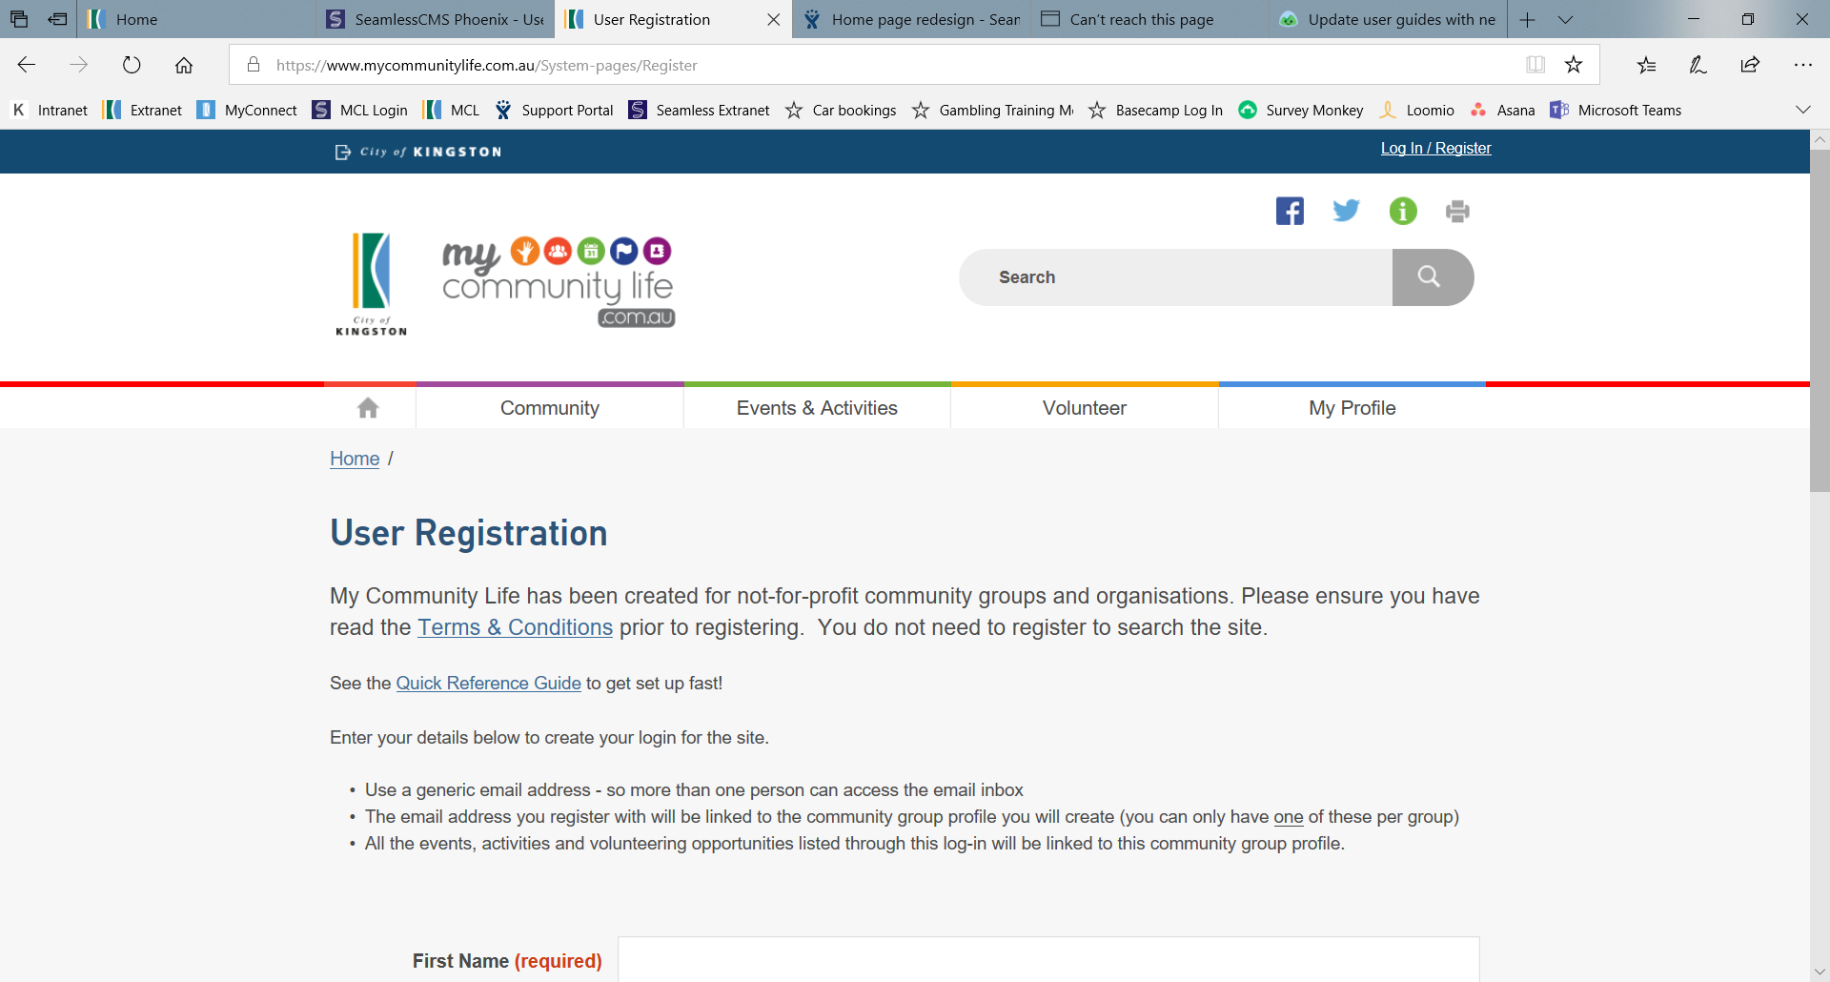
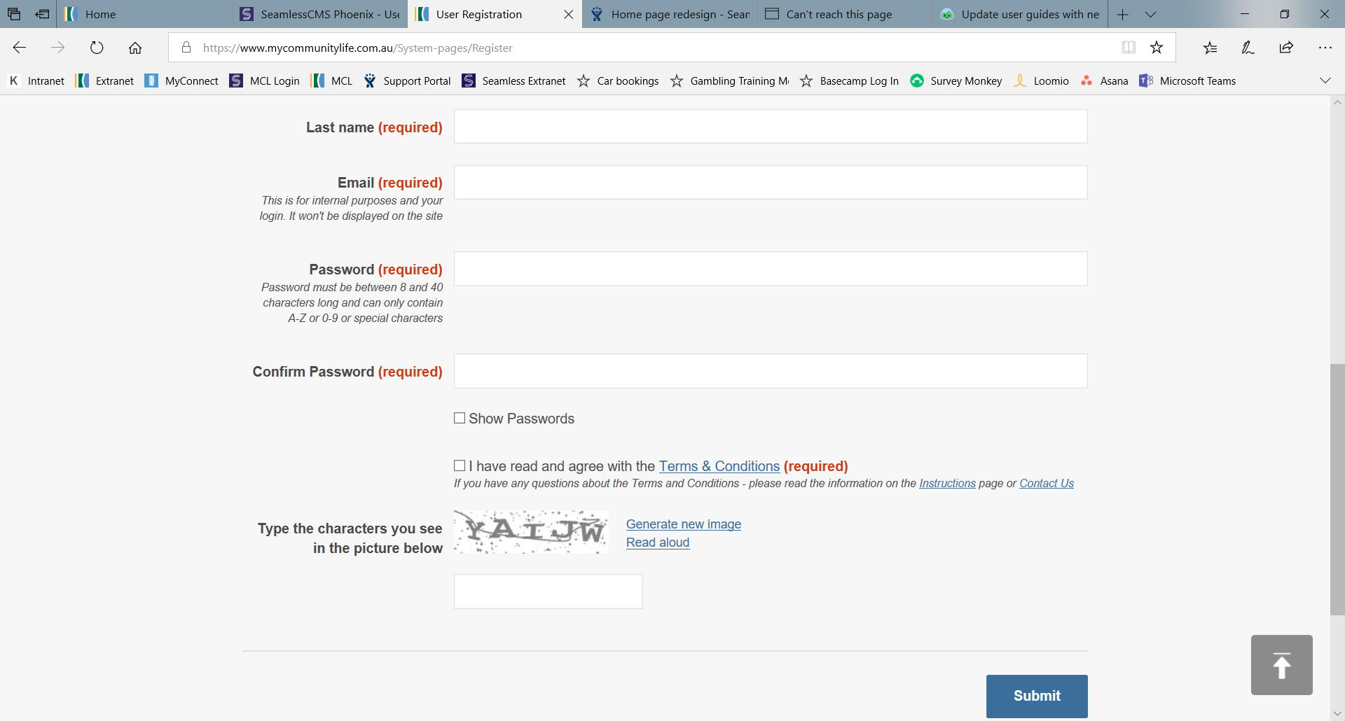
To create a user account/log in complete all fields on the registration page (as shown).
See tip on previous page about choosing an email account
See tip on previous page about choosing a good password
1
2

1
You must ensure that you read and agree to the terms and conditions of use by clicking on the tick box.
- After completing all the fields, click on ‘Submit’. You will be taken to a page telling you that your registration has been successful and you will now be able to log in using your email and password.

Once you complete your user account/login and have logged in to the site, you will see this page. You can tell you are logged in because it will show your name in the top right hand corner of the screen. This is where you can log out too.
1
2
3

These buttons appear faded and cannot be selected until after you have created a live community group listing (completed Step 2).
3
- You can update your password, name and other account details at any time by clicking on the ‘Update Account’ button.
- This is where you begin Step Two – Create a Community Group Listing/ Profile page.
- This is where you begin Step Three – Adding/editing events and volunteer opportunities.

TIP: Preparing to upload good content to the site
Before you begin uploading content on MCL, look through the next few pages to see what information you need and prepare it first to make uploading quick and easy. Here are some tips.
- Use key words in your headings and introductory paragraphs – the search function on the MCL site searches headings first, then introductory paragraphs, then the rest of the content – think about keywords that people would associate with your group and activities, and what they would be likely to type into Google if they were searching for your group or events. List all the keywords and use the most relevant in your headings and introductory paragraphs so your listings will be easier for people to find.
- Use clear language to appeal to your audience – how will people benefit from being part of your group or activity? Who is welcome to participate? What will they get to do?
- Use good photos – pictures tell a thousand words, so try and use photos that show your group or activity in action, or an image that clearly relates to what your groups does (e.g. running). Pictures of groups of people standing or dark, blurry photos are not as appealing. If the images you are planning to use are named something like IMG001.jpeg you should rename them using keywords from your list (e.g. keyword.jpeg).
- Make sure people can reach you on the contact information you provide – people will be put off if they try and contact you and don’t hear back within a day or so. List multiple contact options, or be specific about what times and days you can be contacted.
- Ensure you adhere to the Terms and Conditions of using the site – you can access a copy through the ‘About this site’ link in the footer (bottom) of the MCL webpage.
  - Step 2 - Creating and editing a community group
You must have a user account and be logged in before you can add information to the MCL site.
Adding a Community Group will mean that this group can then be found under the ‘Community’ tab on the MCL site and people can search for the group.
Add a new Community Group by clicking on the ‘My Profile’ tab in the main menu. Make sure you are logged in and then select ‘Add New Group’. A registration page titled ‘Add/Edit Community Group’ will appear for you to complete (see example on the next page). Some of this information you must have to register the page, the rest is optional.
It is highly recommended that you use this guide to gather and prepare all the information for your Community Group listing before starting to work on the form online. That way it will be much faster and easier to copy the information into the online form.
Required information (marked in red on the form, see images on page 17 and 18):
- Group name – the name of your community group
- Group summary – a one sentence description of your group (remember to use key words)
- Group image – a good photo or logo, or select from the options provided
- Street address, suburb and postcode – if your group does not have a fixed address, you can enter the address of where you most often meet. This will be used to pinpoint your location on a map on your community group webpage.

Optional (recommended) information:

Step 1 of 5: Group Details:

- Group detailed description – this is where you explain what your group does (remember to think about what will appeal to your audience and your keyword list). It is highly recommended that you add information here or your page will look quite blank.
- Opening hours (if relevant) – or what time your group meets.
- Category – select the category(ies) that are relevant to your community group from the list provided. It is recommended that you select a maximum of 3 categories.
Step 2 of 5: Contact Details:
- Contact name, number and email address – these are the main contact details for your group, you can use other more specific details when registering events etc. Consider using a generic email address here (see tip box on page 11 for more information). You can list other contact options in the ‘Description’ box if necessary. Remember this is a public site so only list details you are happy for anyone from the community to contact.
- Group website – if you already have a website this is a great way to direct people to it.
Step 3 of 5: Location Details:
- Venue Name – the name of the place the group usually meets
- Local transport – provide information about how to reach you by public transport for people that may not have access to a car (if relevant)
- Other locations - list any other locations that you meet or operate from (if relevant)
- Postal address – Postal address for the group (if different from address)
Step 4 of 5: Accessibility Details:
- Accessibility options – choose all options that are relevant from a list. This explains how people can access the location of your community group or participate in your activity if they have specific requirements
- Number of steps – if the venue has steps at the entrance, please specify how many
- Number of accessible carparks – number of car spaces dedicated to accessible (disabled) parking
Step 5 of 5: Related Information:
- Related websites – are there other websites that are relevant to what your group does (e.g. are you a local branch of a larger organisation, do you partner with another group?). This is also where you can add links to your social media pages.
- Related documents – do you have documents that contain relevant information to share with prospective members? (e.g. meeting schedule, Terms of Reference, fee schedules). You can add up to 10 documents.

- Preview: Allows you to preview what your listing will look like before you submit it for approval.
- Submit: Submit your community group listing to Kingston Council for approval
TIP: Uploading documents
When uploading documents, there are some simple things to keep in mind to make sure they are easy for people to open and read.
- Always use a clear title – Use the Group Name, keywords and a descriptive heading so people know what they are reading about
- Upload documents in Microsoft Word or PDF formats – these are common formats that will be able to be opened by all computers. Microsoft word files are required so they can be read by people using screen readers.
- Include the date or version number – this will help you make sure people are using the most up to date information
- Use a minimum of size 11 font – this will help make sure that your documents can be read easily. You may want to make your font even bigger depending on the needs of your audience.
- Save the document using a clear, descriptive file name – this will make it easy for people to know which document they want to open.

Add/Edit Community Group page
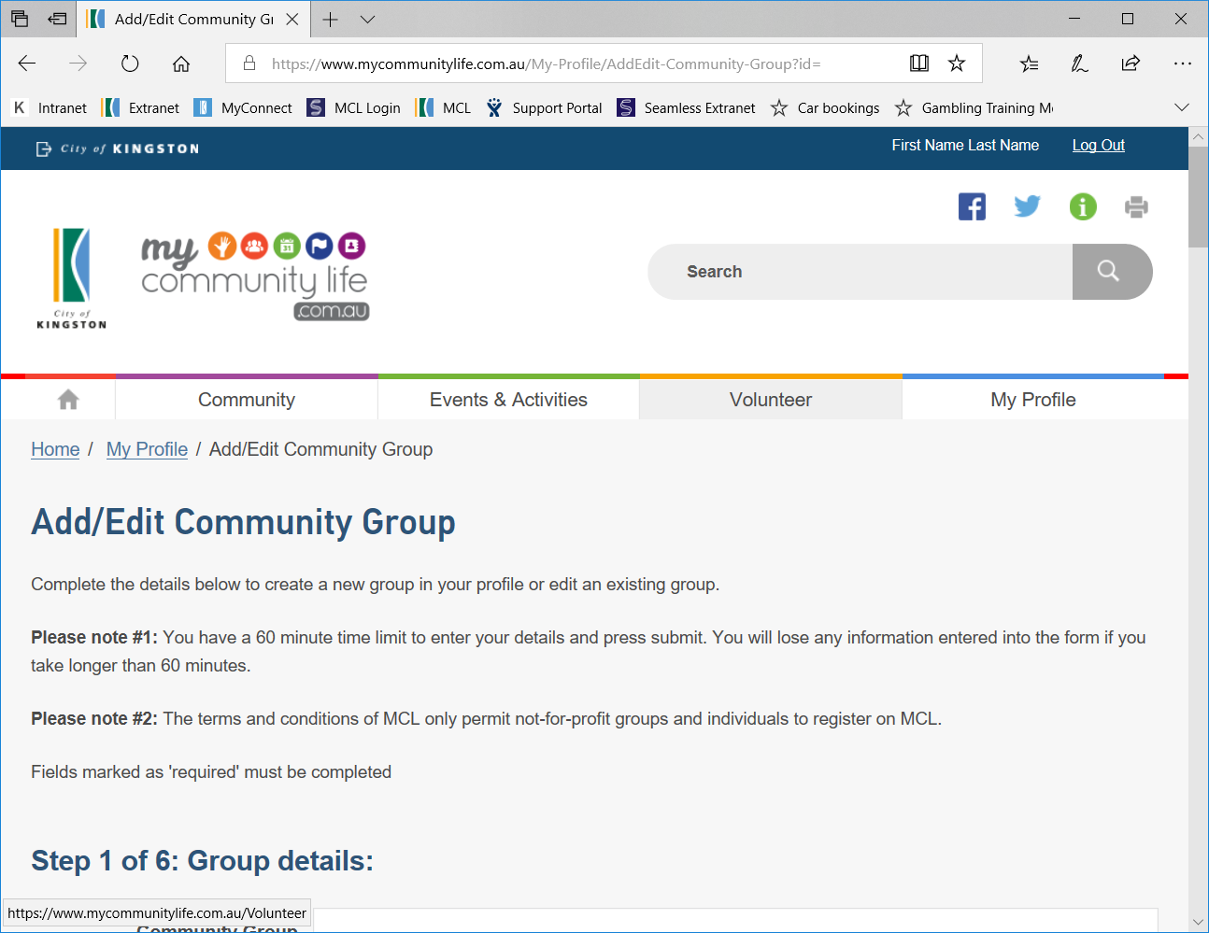
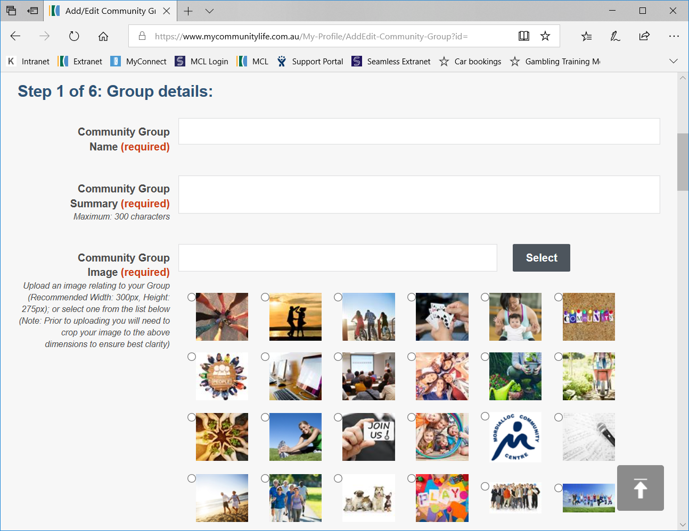

Mandatory fields are marked (required)

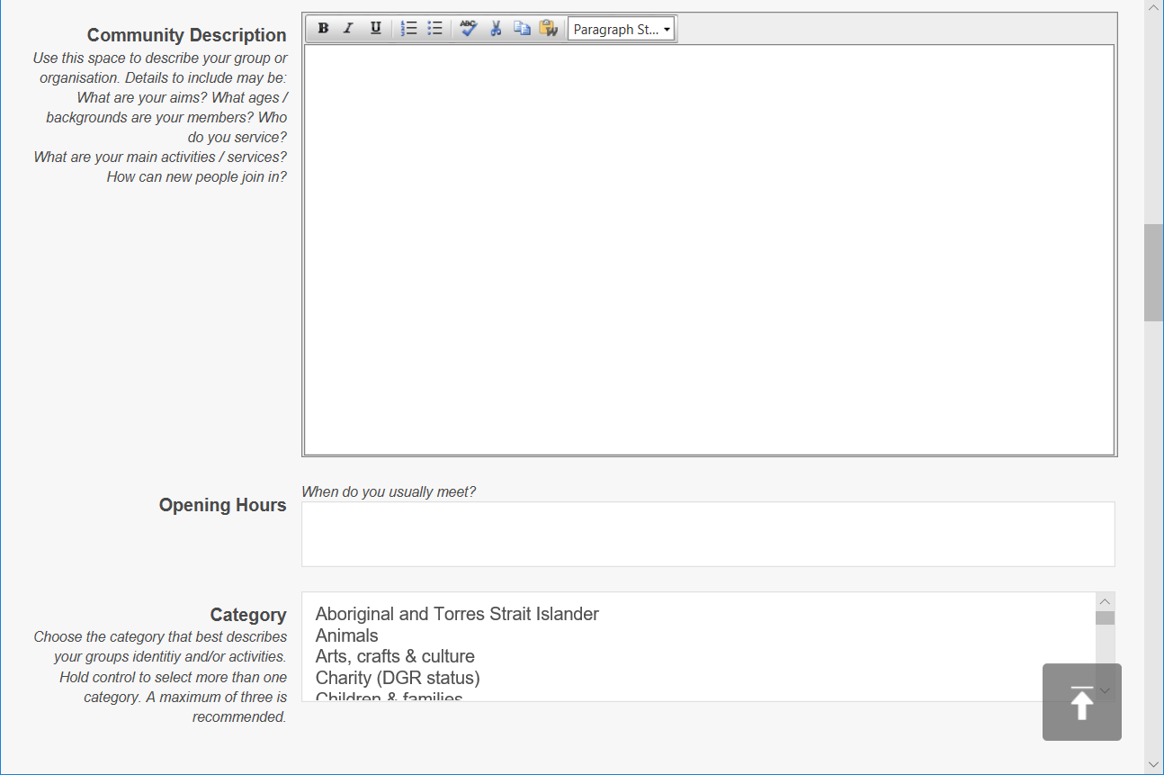

Additional instructions and prompts are provided on the form to help you

Add/Edit Community Group page continued
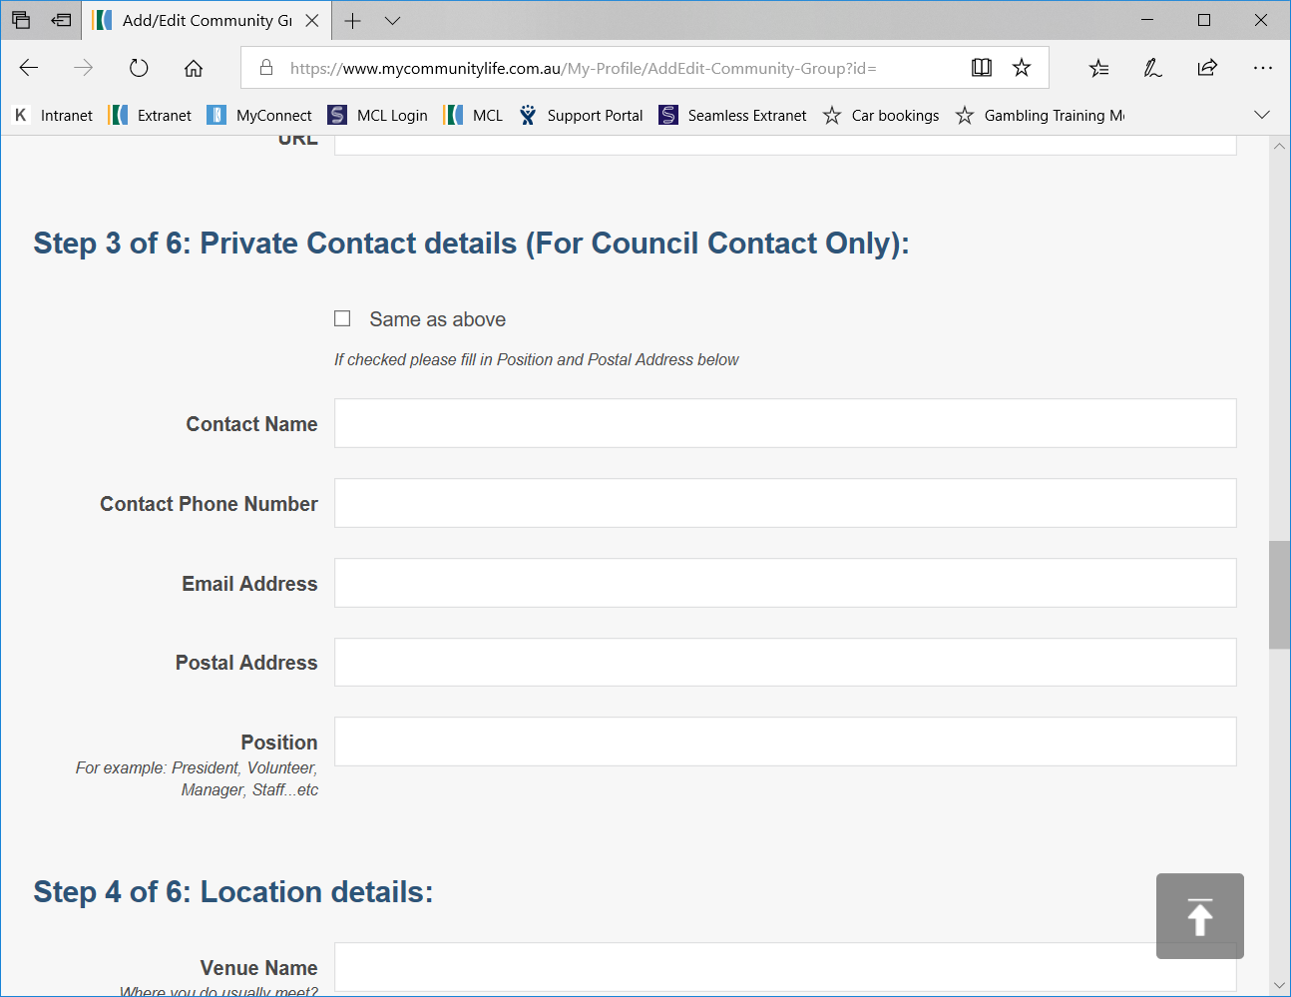

Add/Edit Community Group page continued
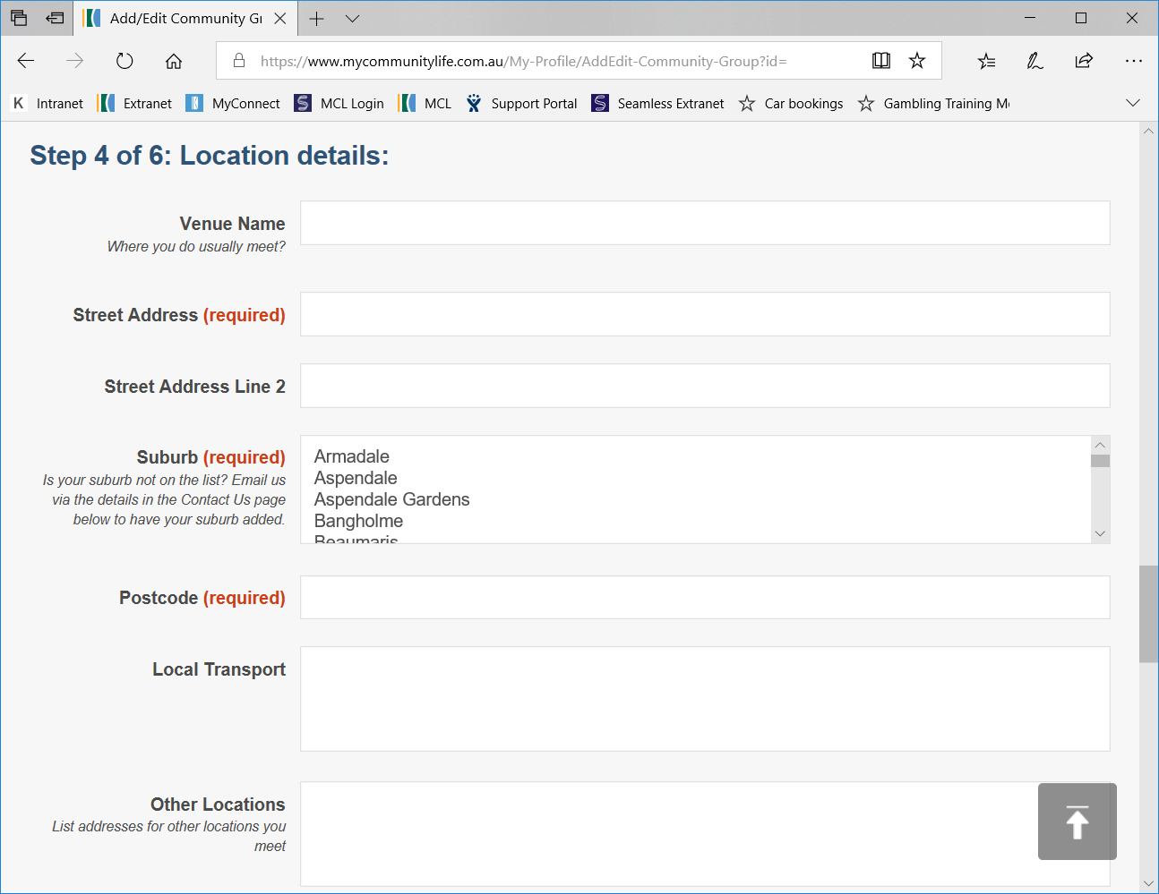

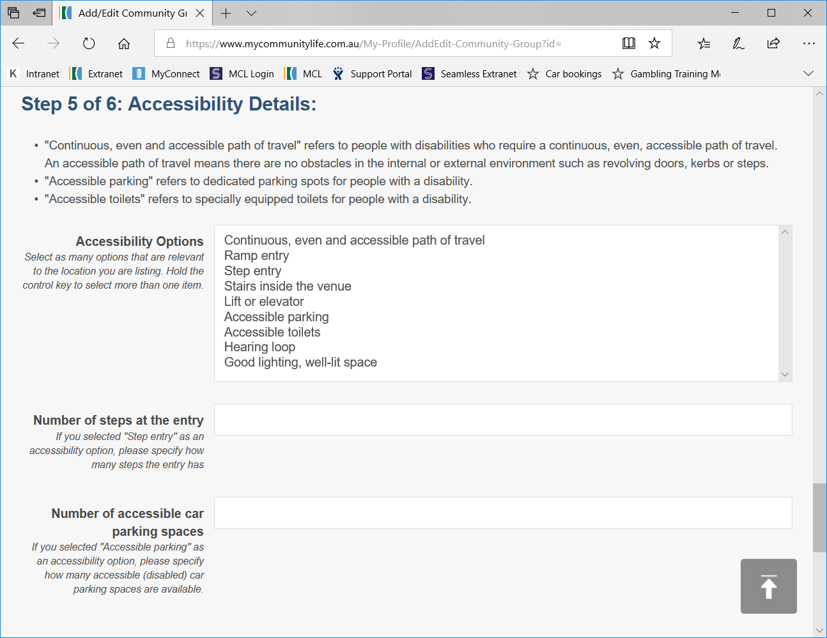
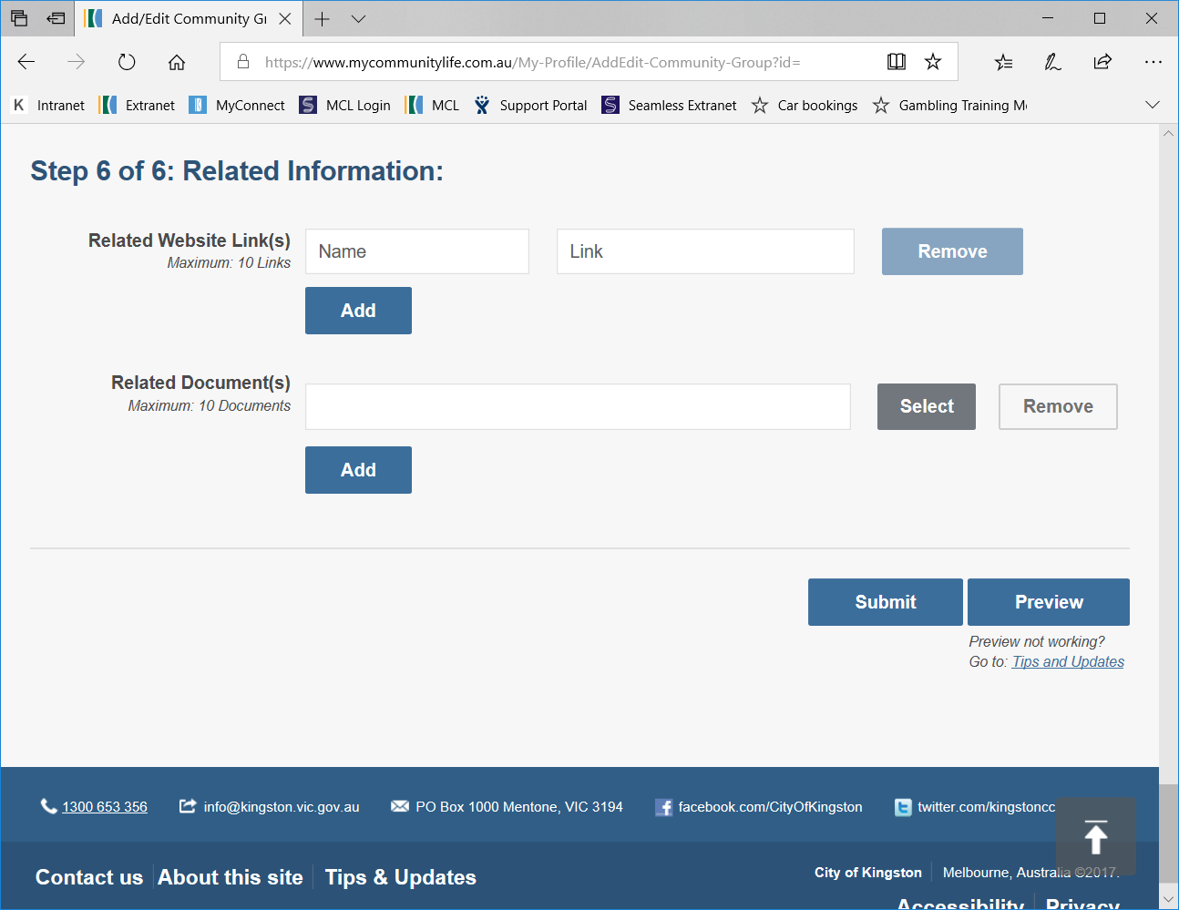

See TIP on page 16

Once you have finished adding all the information about your Community Group, click the ‘Submit’ button at the bottom of the page. This will send a notification to Council to review your information and approve it.

Please allow three business days for your Community Group page to be reviewed and approved by Council. You will be contacted by Council if there are any changes or further information required before it can be approved.

Once your Community Group has been approved and listed successfully, your ‘My Profile’ screen will appear as shown.

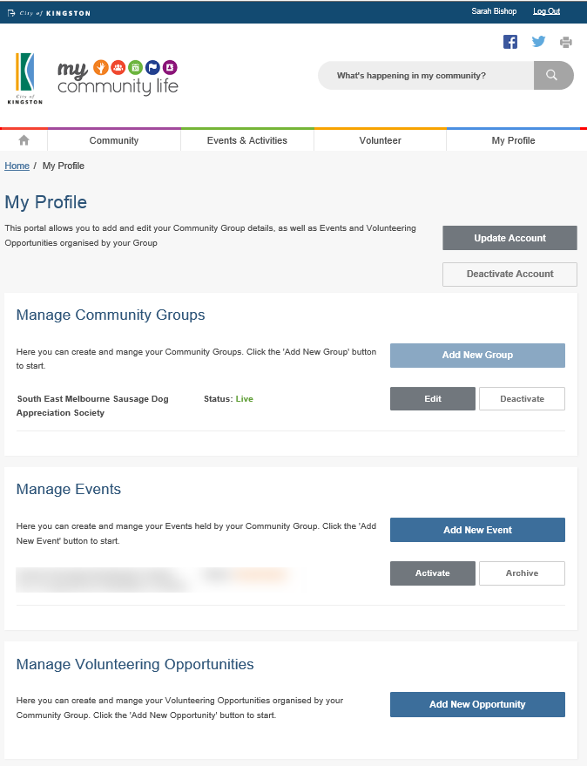
2
1
- As you have already registered a Community Group, you can see the Group you have listed at the status of the listing (see green circle). The status will say ‘live’ when the page is up on the MCL site, or ‘Pending Approval’ when your page is waiting to be approved by Council. You can ‘Edit’ or ‘Deactivate’ the listing using the buttons available.
- Now that you have completed Step 2 – Create a Community Group listing, you can begin Step 3 – adding/editing events and volunteer opportunities. These buttons will now appear in blue (not faded).

Editing a community group listing
To edit an existing Community Group listing, click on the ‘Edit’ tab under the ‘Manage Community Groups’ heading on your ‘My Profile’ page. This will take you to the ‘Add/Edit Community Group’ form and will show the information you have already entered, which you can then edit.
Please note that once you edit the listing it will need to be re-submitted to Council for approval. Please allow three business days for your revised Community Group page to be reviewed and approved by Council. You will be contacted by Council if there are any changes or further information required before it can be approved.

  - Step 3 – Adding and editing events and volunteer opportunities
You must have a Community Group listing before you can add an event or activity, or volunteer opportunity to the MCL site. You cannot add an event or volunteer opportunity while your Community Group listing is ‘pending approval’ (this includes if you have just edited your community group listing and it is waiting re-approval).
Adding an Event and Activity or Volunteer Opportunity will mean that it can then be found under the relevant tab on the MCL homepage and people can search for it.
Adding an Event or Activity
Add a new Event or Activity by clicking on the ‘My Profile’ tab in the main menu. Make sure you are logged in and then select ‘Add New Event’. A registration page titled ‘Add/Edit Event’ will appear for you to complete (see example page 22-23). Some of this information you must have to register the page, the rest is optional.
Required (must have) information:
- Event name – use common words to make it easy to find
- Event summary – a one sentence description of your event (remember to use key words)
- Event type – select the appropriate option(s) from the list provided
- Event image - a good photo that shows what the event is about
- Event date – click on the ‘set date’ link and complete the information in the pop up box.
  - Single date – choose for an event that srtarts and finishes on the same day
  - Time span – select when an event will be held over several days (e.g. Saturday & Sunday)
  - Multiple dates – select when an event will be held over several different dates (e.g. Monday, Wednesday and Saurday). Select ‘Add Date & Time’ to add additional dates
  - Reoccuring dates – select when an event will be reoccuring regularly on a daily, weekly, monthly or yearly basis
- Street address, suburb and postcode – the location your event will be held. This will be used to pinpoint your location on a map on your event listing. If you event is held in multiple loations enter the main location and include the other location information in the ‘Event Description’ box
Optional (recommended) information:
- Event Description – this is where you explain all about your event (remember to think about what will appeal to your audience). If your event has multiple dates, times or locations this is where you can add that information.
- Cost (if relevant) and Ticket booking website – if you are planning on selling online tickets for your event include the link to the website here (see tip box on the next page for more information)

- Contact name, number and email address – these are the specific contact details for your event or activity. They may be the same or different to your general contact details for your Community Group. Consider using a generic email address here (see tip box on page 10 for more information). You can list other contact options in the ‘Description’ box if necessary.
(Tip: The email address that you used in your user registration/log in will automatically appear in the email field, remember to change it if there is an alternative contact for your event).
- Local transport – provide information about how to get to the event by public transport for people that may not have access to a car (if relevant). For big events it’s also a good idea to provide information about parking.
- Related websites – add links to other websites that are relevant to your event or activity (e.g. is it a local event of a larger initiative). This is also where you can add links to your social media pages.
- Related documents – do you have documents that contain relevant information to share with people about your event (e.g. a list of what to bring, event program). You can add up to 10 documents (see tip box on page 14 for more information)
Add/Edit Event page
TIP: Using online event ticketing websites
There are a number of websites that you can use to issue free or paid tickets for your events, such as:
- Eventbrite – www.eventbrite.com.au
- TryBooking – www.trybooking.com.au
These sites allow people to register, pay (if required) and print tickets to your event. If your event is free there is no charge to use these sites. If you are charging for your event, you will be required to pay a percentage of the ticket price.
Using online ticketing sites can save a lot of time and help you keep track of attendance easily. Once you register your event on an online booking site, you simply need to include the link the booking site has provided you on your event page on MCL.

Once you have finished adding all the information about your event or activity, click the ‘Submit’ button at the bottom of the page. This will send a notification to Council to review your information and approve it.
Please allow three business days for your event or activity page to be reviewed and approved by Council. You will be contacted by Council if there are any changes or further information required before it can be approved.
Once your Event or Activity has been approved and listed successfully, you will be able to see it as ‘live’ on your My Profile screen, the same way you can see your Community Group listing.
Tip – If your event is seasonal or runs every year, after your event or activity is finished it will be deactivated. This means that it will no longer appear on the MCL site, but you can ‘reactivate and edit’ it at a later date with the new details rather than re-creating the whole event/activity again from scratch.
Adding a Volunteer Opportunity
Add a new Volunteer Opportunity by clicking on the ‘My Profile’ tab in the main menu. Make sure you are logged in and then select ‘Add New Opportunity’. A registration page will appear for you to complete titled ‘Add/Edit Volunteer Opportunity’ (see example pages 25-26). Some of this information you must have to register the page, the rest is optional.
Required (must have) information:
- Volunteer role – the name (title) of the volunteer position.
- Brief description of duties – a one sentence description of the role (remember to use key words)
- Role image – a good photo that shows what the role is about.
- Term of role - select the appropriate option(s) from the list provided.
- Interested in – select the option(s) that apply from the list provided.
- Contact name and email – these are the specific contact details for your volunteer opportunity. They may be the same or different to your general contact details for your Community Group.
- Street address, suburb and postcode – the location that the volunteer will be required. This will be used to pinpoint the location on a map on your volunteer opportunity listing. If your volunteer opportunity does not have a required address, use the location listed for your community group and explain that there is no set location in the ‘Role Description’ box.
Optional (recommended) information:
- Role Description – this is where you explain all about the volunteer position (remember to think about what your audience will want to know. Be sure to state the benefits that the person will get from volunteering (e.g. gaining new skills, meeting a community of great people, getting exercise).
- Role Requirements – select the option(s) that apply from the list provided.
- Local transport – provide information about how the volunteer can get to the required location by public transport as some people may not have access to a car (if relevant).
- Related websites – add links to other websites that are relevant to the volunteer opportunity (e.g. a link to information about how to get a police check, or a link to your website to find out more about what you do). This is where you can also add links to your social media pages
- Related documents - do you have documents that contain relevant information to share with people about your event (e.g. a position description or volunteer policy). You can add up to 10 documents (see tip box on page 14 for more information).

Add/Edit Volunteer opportunity page

Once you have finished adding all the information about the volunteer opportunity, click the ‘Submit’ button at the bottom of the page. This will send a notification to Council to review your information and approve it.

Please allow three business days for your volunteer opportunity page to be reviewed and approved by Council. You will be contacted by Council if there are any changes or further information required before it can be approved.

Once your Volunteer Opportunity has been approved and listed successfully, you will be able to see it as ‘live’ on your My Profile screen, the same way you can see your Community Group listing. Tip – If your volunteer opportunity is seasonal or is a position that you regularly need to recruit for, after the position is filled you can ‘deactivate’ the volunteer opportunity listing. This means that it will no longer appear on the MCL site, but you can ‘reactivate and edit’ it at a later date with the new details rather than re-creating the whole listing again from scratch.
Editing an Event or Volunteer Opportunity
To edit an Event or Volunteer Opportunity, click on the ‘Edit’ tab under the relevant heading on your ‘My Profile’ page. This will take you to the relevant page where you can modify the information.
Please note that once you edit the listing it will need to be re-submitted to Council for approval. Please allow three business days for your revised Event or Volunteer Opportunity listing to be reviewed and approved by Council. You will be contacted by Council if there are any changes or further information required before it can be approved.

- Removing content from the site
There are two ways to remove content from the MCL site:
- Deactivate – this allows you to turn the page off so that it doesn’t appear on the website, but keep it and turn it back on at a later date
- Archive – this is how you permanently remove content from the MCL site. To do so you need to deactivate it first, then archive it.
You must have a user account and be logged in before you can deactivate or archive information from the MCL site.

  - Deactivating or archiving a community group listing, events and volunteer opportunities
To deactivate a Community Group, Event or Volunteer Opportunity, click on the ‘Deactivate’ tab under the relevant heading on the user account/ log in page. A box will pop up confirming whether you would like to deactivate the listing, click OK to proceed, or Cancel to go back.
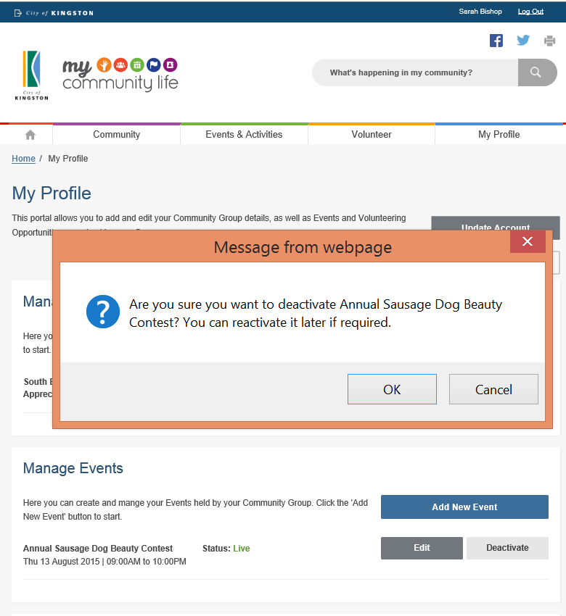

You can see which listings are ‘live’ and which are ‘deactivated’ on the user account/ log in screen. You can easily reactivate listings by clicking on the ‘Activate’ button.
Please note that once you re-activate the listing it will need to be re-submitted to Council for approval. Please allow three business days for your revised Event or Volunteer Opportunity listing to be reviewed and approved by Council.
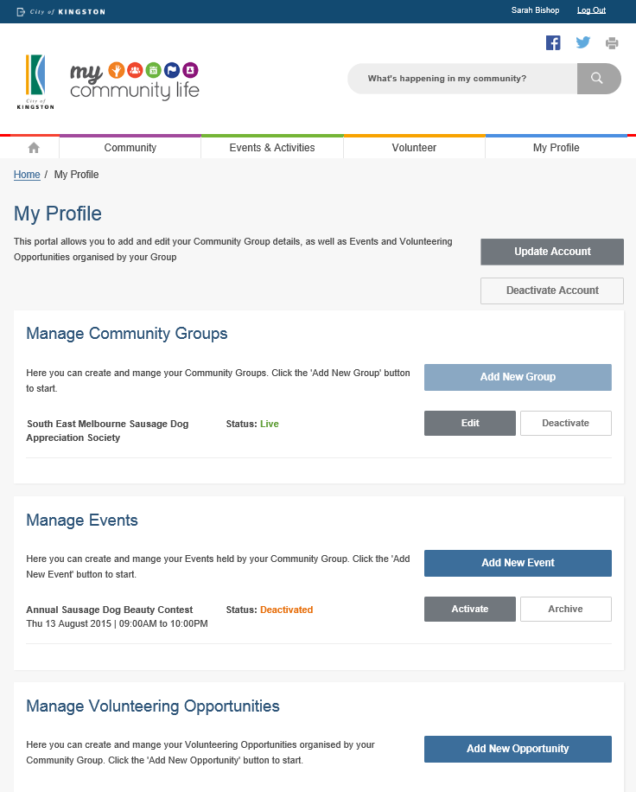
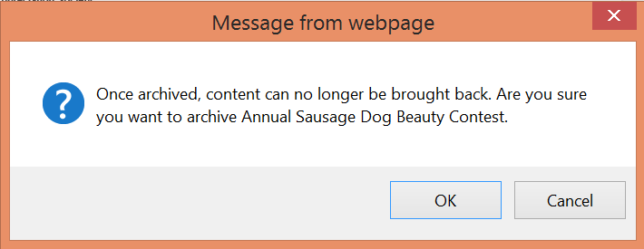
To archive a listing (permanently delete it), click on the ‘Archive’ button. This option will only appear once the listing has been deactivated. A box will pop up confirming whether you would like to archive the listing, click OK to proceed, or Cancel to go back.

  - Deactivating your user account/ log in
Deactivating a user account/ log in will not automatically deactivate Community Group, Event or Volunteer Opportunities created with that user account. This must be done before you deactivate your account following the steps outlined in the previous section.
To deactivate your user account/ log in, click on the ‘Deactivate Account’ tab on the user account/ log in page. This will take you to a new page where you will be asked to confirm whether you would like to continue with the deactivation.
Select ‘Delete my account’ if you wish to remove your account completely.
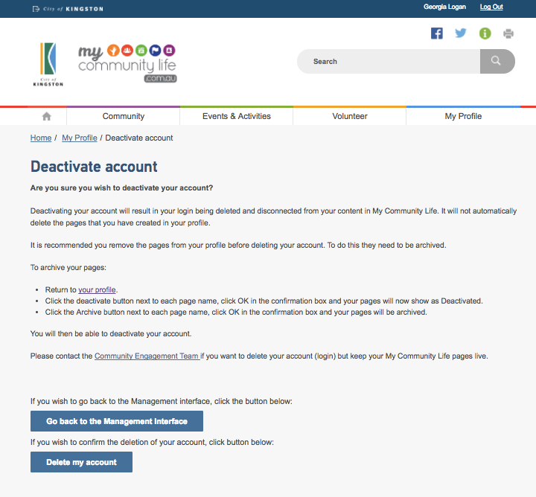

- Getting the most from MCL
The My Community Life website is a great place to promote your group, events and volunteer opportunities. Council promotes the MCL site through a range of channels such as Kingston Your City, the main Kingston Council website, social media and newspaper advertisements.

To get your information to the widest audience, it is also recommended that you promote your MCL pages using a range of activities, such as:
- Linking your MCL pages to and from your existing community group website
- Promoting your MCL pages using social media (refer to tip below)
- Including information about your MCL pages in your community group newsletter
- Talking about your MCL pages to all your members and showing them how to find and use the site
- Directing community members to the site whenever you get an enquiry
- Working with other community groups to cross promote events via social media. The more traffic we all bring to the site the better the outcomes for all groups.

Just as important as promotion, is making sure that you have great content on the MCL site. You want people to be able to find all the information they need when they get there. If people can’t easily find the information they are looking for, or the information is not up to date or reliable, they will probably not use the site again.

To make your content as valuable as possible you need to:
- Make sure it is always up to date
- List all your events and opportunities
- Use eye catching photos
- Carefully choose the words you use in headings, descriptions and key words. Use simple common words as these are what show up best in the search results
- Think about including case studies or quotes from members, event participants or current volunteers (you can even video them, load them onto YouTube and link to them from your page)
- Be creative and have fun.
TIP: Using social media
Council has developed a guide that explains how you can use social media to help promote your group, events and volunteer opportunities.
Contact the My Community Life team for an electronic copy of a video tutorial, called a webinar.

